You get us both
We work in partnership with you and utilizing each of our strengths, networks and experience we are both always working for you.

Bill Raine

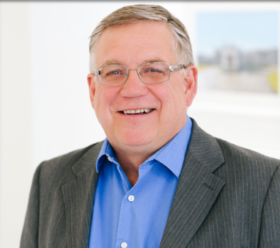

Bill Raine has been successfully owning and operating small businesses in the Okanagan since 1990. Bill has fine-tuned every aspect of buying, selling and investing in real estate. Bill is known for his professional expertise, sophisticated resources and dedicated customer services. Bill is a true professional and understands what it takes to be a business person in today’s market. Bill is your “Full Service REALTOR®” being licensed as both a Commercial and Residential REALTOR®.

Mark Coons

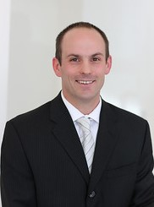

Mark has a Bachelor of Business Administration Degree and Certificate in Economics from the University of Regina. After getting his degree Mark had a successful 5 years in lending with Farm Credit Canada, where he lent over $120M during that time. Being inspired and watching small businesses grow was a rewarding experience and it inspired him to start his Real Estate career. Having the educational and financial experience Mark will ensure to maximize your bottom line.

